Section one, block Bourke Street, Swanston Street, Collins Street and Elizabeth Street

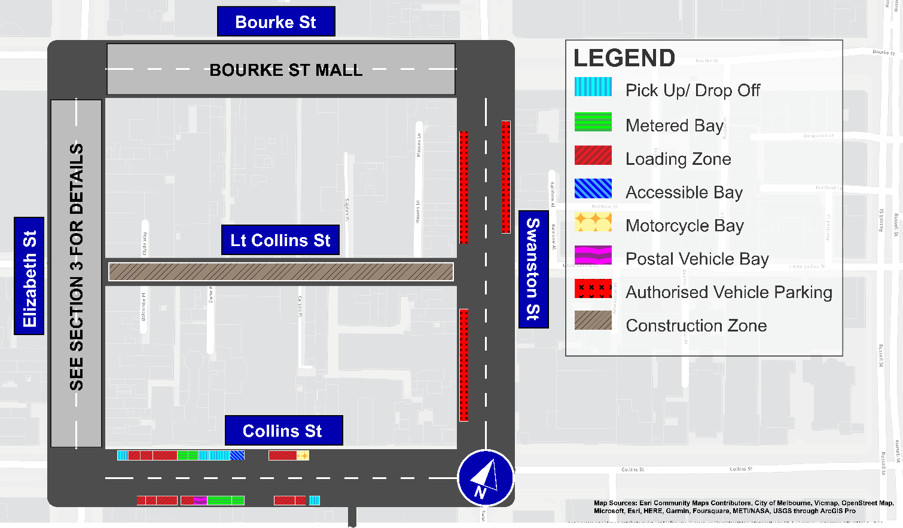 This map presents the parking conditions to be applied within this block as part of the CBD parking improvement project.

Collins Street
The north side, from west to east will include one pick up/drop off space, followed by four loading zones, two metered parking spaces, three pick up/drop off spaces, one accessible parking space, two loading zones and one motorcycle parking area.

The south side, from east to west will include one pick up/drop off space, followed by three loading zones, three metered parking spaces, one postal vehicle space and five loading zones.

Swanston Street
The west side will include two areas of authorised vehicle parking. The east side will include one area of authorised vehicle parking.

Bourke Street Mall
Permited vehicle access only.

Little Collins Street
Currently has no parking due to a construction zone.

Elizabeth Street
See Section Three for details.

Parking controls to be applied
Simplified and consistent parking controls will be applied across the CBD.
Pick up/drop off spaces will typically be signed ‘No Parking’ with supplementary signage indicating permitted use of the space for passenger pick up/drop off with a 2 minute limit.
Metered parking spaces will typically be signed 2P meter, 7am to 10pm, Monday to Sunday
Loading Zones will typically be signed as 30 time limited spaces from 7am to 4pm Monday to Friday. Loading Zones will typically be converted to 2P meter parking spaces from 4pm to 10pm, Monday to Friday and 7am to 10pm Saturday and Sunday.
Accessible parking spaces will typically be signed 2P, 7am to 10pm, Monday to Sunday
Motorcycle parking is signed as a designated motorcycle parking area with no time restrictions
Postal vehicle spaces will typically be signed as ‘No Parking postal vehicles excepted’
Authorised vehicle parking refers to access for permitted uses only
Construction Zone is signed as ‘Permit Zone’ to facilitate temporary use of street space for building construction.

