

Artwork Guidelines for Developers

Creative Hoardings trial

2023-24

Contents

1. Invitation to participate 3

2. Benefits 3

3. Selection of artwork 4

3.1. Independent commissioning 5

4. Layout of design 5

4.1 Artwork and artwork information panel 5

4.2 Artwork and first party advertising 6

4.3 Doorways and Safety Signage 6

4.4 Sloping and irregular shaped hoardings 7

4.5 Corners and doorways in hoardings 8

5. Submit for approval 9

5.1 Approval provisos 9

6. Printing and installation 9

7. Contact us 9

# 1. Invitation to participate

Melbourne is a creative city, and we are bringing local art to our streets with a 12-month trial to transform hoardings around Melbourne construction sites. The trial seeks to establish the benefits of an ongoing creative hoardings program to improve the public realm experience.

* City of Melbourne has commissioned five unique artworks to add colour and vibrancy, improving the look and feel of our streets, as well as improving the quality of experience for visitors, workers and local businesses.
* The program is an opt-in trial that focuses on commercial construction projects longer than 12 weeks and will provide insights to determine if the program should be rolled out more widely in the future.
* The city provides artwork free of charge to those taking part in the trial however, costs associated with the layout, printing and installation of the artwork will need to be covered by the participating developer. The City of Melbourne will assist with advice and consultation.

If you have a current or forthcoming site that you believe could benefit from artwork and wish to participate in this trial the City of Melbourne would like to hear from you.

# 2. Benefits

Many construction sites already utilise their hoardings for promotional advertising under the Melbourne Planning Scheme. Under the planning scheme, one advertising panel of less than 10 m² is exempt from requiring planning permission.

* This trial promotes the use of the remaining hoarding space for artwork, which will attract attention to the hoardings and in turn the promotional advertising.
* The commissioned artworks will also uplift and transform the construction hoardings, adding excitement and visual appeal.
* Hoarding artwork can reduce occurrences of graffiti and vandalism.
* Similar programs, both national and internationally, have found that artwork enhances the appearance of construction hoardings, assists in minimising the visual impact of construction and supports local artists.

# 3. Selection of artwork

The first step in the process of integrating artwork into your site hoardings is the selection of artwork.

The following five original artworks are available to developers as high-resolution, print-ready files to download, print, and install onto construction hoardings within the City of Melbourne. Their modular design enables all site hoardings, no matter their length, to have continual and endlessly repeated artwork.

Image depicts artwork by Patrick Pound, titled The Resistors.
Artwork is comprised of nine vintage photographs of different people with their hands shielding their faces from the photographer.

From left to right - black and white image of man man turining away from the camera, nurse shields face from photographer, black and white portait of woman peeking through her fingers, woman in red top with both hands in front of her face, black and white photo of man on couch with hand up, person in bed covering their face with a yellow blanket, black and white portait of woman with hand partially covering her face, woman in jumpsuit walking with hand up, woman on speedboat covering her face with a cup

Figure : Patrick Pound, *The Resistors*

Image depicts artwork by Olso Davis, titled The Readers
Artwork is comprised of ten different drawings of characters reading a book on different types of chairs. Artwork uses a combination of red, teal and navy colours.

From left to right - Fish reading on a lounging chair, nun reading on a camping chair, older woman reading on an antique chair, sea captain reading on a bean bag, child reading on a rocking chair, ghost reading on a stool, picasso-esque character reading at a school desk, yeti character reading on a tree stump, man reading in a metal chair, cowboy reading on an inflatable ball.

Figure : Oslo Davis, *The Readers*

Image depicts artwork by Eric Jong, titled Through a LiDAR sparsley.
Artwork is comprised of ten screenshots of the interior of different buildings across Melbourne using LiDAR and Photogrammerty scans. There are QR codes in the corner of each image that will allow viewers to explore the full 3d scans hosted online.

Figure : Eric Jong, *Through a LiDAR sparsely*

Image depicts artwork by Madeleine Joy Dawes, titled Overlooking the Star (What’s Chasing You)
Artwork is comprised of many black, white and grey pixels which create a lager image and can also be viewed up close. 

Figure : Madeleine Joy Dawes, *Overlooking the Star (What’s Chasing You)*

Image depicts artwork by Nina Sanadze, titled Reshaping Monuments.
Artwork is comprised of six images depicting clay models, deconstructed monuments and statues.

From left to right: mound of brown clay, human-shaped statue on a chair with brown clay creating the torso on a white sheet, grey clay and portions of a deconstructed statue on black and white fabric background, statue and brown clay on white and red fabric with arm reaching into frame, two human faces from statues with clay on a black background, deconstructed white statue on black background with arm reachin in to frame

Figure : Nina Sanadze, *Reshaping Monuments*

## 3.1. Independent commissioning

If you wish to use an independent artist to design a new work we can offer a list of suitable artists from our database of more than 200 artists who have experience in producing murals.

We also offer a range of support for developers on commissioning an artwork independently, including sample contracts, advice on fees and a review process. For more information, please contact the creative hoardings team at [publicart@melbourne.vic.gov.au](mailto:publicart@melbourne.vic.gov.au).

# 4. Layout of design

As part of the approval process, the artwork should be presented as an InDesign file or pdf format. The Creative Hoarding Project Officer can advise on the following:

* The customised site hoarding layout provided will show how artwork would be placed on construction hoardings, including corners, sloped and irregular hoardings.
* Artwork is not required on gantries or scaffolding, only at street level.
* City of Melbourne artwork information panels (templates are provided along with artwork files) are shown in correct location at the end of a hoarding and/or next to first party advertising.
* First party advertising and construction project information is shown at correct size and placed correctly at the end of a hoarding. Artwork should not be interrupted by advertising or information panels.
* Safety and site signage are shown located around doors and gates as per to code.

## 4.1 Artwork and artwork information panel

Figure 6: depicts mock up of how artwork on hoardings should be displayed with artwork information panel. mock up features artwork by Patrick Pound, The Resistors.
Instructions on image:
Placement: One information panel per street frontage. This panel should be located t one of the possible two ends of hoarding
Artwork: The design is provided in several modular sections and can be arranged in various order.
Information panel: Artwork, artist and trial project information, including any QR codes relating to the artwork. City of Melbourne branding. The customised information panel file will be provided along with the artwork files.

Figure 6: Artwork: Patrick Pound, *The Resistors*

## 4.2 Artwork and first party advertising

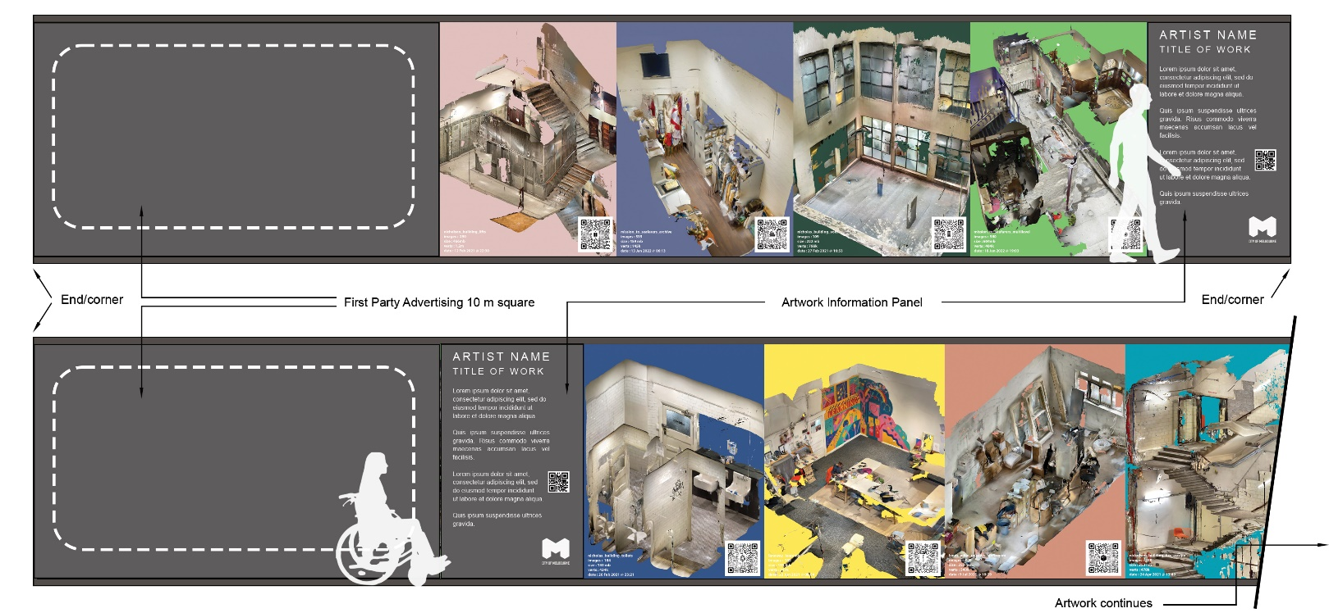 **Figure 7: Artwork: Eric Jong, *Through a LiDAR sparsely***

One advertising panel less than 10 m² that is publicising the sale or letting of the property on which it is displayed is exempt from planning permission under the Melbourne Planning Scheme. If there are multiple street frontages and you are seeking an advertising panel for each street frontage, you will require separate planning permission.

Each street frontage requires one artwork information panel located at the beginning or end of the hoarding. When advertising appears on the same hoarding, the advertising and artwork information panel are either at opposite ends of the hoarding, or side by side at one end. The artwork should not be broken up by information or advertising.

## 4.3 Doorways and Safety Signage

Figure 8 depicts instructions and mock up of how artwork should be displayed with doorways and safey signage. Mock up features artwork by Oslo Davis, The Readers.
Information on image:
Timber plinth max 150 mm high and 25 mm thick
Gate to swing inward or slide internally
Minimum 12 mm thick timber panels
Doorways that measure less than 2m wide does not need to display artwork
Safety signage and developer construction project panels, corporate logos, builder's name, consultants

Figure 8: Artwork: Oslo Davis, *The Readers*

## 4.4 Sloping and irregular shaped hoardings

Figure 9 depicts instructions and mock up of sloping and irregular shaped hoarings. Mock up features artwork by Nina Sanadze, Reshaping Monuments.
Instructions on image:
When the hoarding is on a slope the artwork should remain parallel to the gradient
One information panel is required for each hoarding frontage located at one of two possible ends
For visual continuity, artwork should remain at full scale when applied to odd shaped hoardings

Figure 9: Artwork: Nina Sanadze, *Reshaping Monuments*

## 4.5 Corners and doorways in hoardings

Figure 10 depicts instructions and mock up of how to display artwork on corners and doorways in hoardings. Mock up features artwork by Madeleine Joy Dawes, Overlooking the star (what’s chasing you)
Instructions on image:
Gate to swing inward or slide internally
Allowance should be made for safety signage and site information around doorways
Artwork should wrap around corners to create a seamless flow

Figure 10: Artwork: Madeleine Joy Dawes, *Overlooking the star (what’s chasing you)*

# 5. Submit for approval

To be done at the time of submitting the Town Planning Permit Application.

Please indicate you are interested in taking part in the trial and submit the appropriate files (as described in section 4 of these guidelines) for approval.

Once permits are approved, the artwork is expected to be installed once hoarding construction is completed and remain in place until the removal of said hoardings.

## 5.1 Approval provisos

Request for changes will occur if the design layout is incomplete or incorrect, such as:

* Artwork layout is compromised or inconsistent with these guidelines.
* Artwork Information Panel and/or construction project information are incorrect or missing.
* First party advertising compromises or interrupts artwork.

# 6. Printing and installation

Costs associated to the layout, printing and installation of the artwork is covered by the participating developer. See the below printing requirements:

* Printing and vinyl materials preferably should be high quality, sustainable and flame retardant, using sail track to install.
* UV stabilised ink printed matt (not gloss).
* Printing and installation are in the region of $100 –120 per linear meter (30m hoarding is approximately $3500). This estimate includes site survey, sail track, printing and installation. It does not include permits or pedestrian or traffic control.
* The City of Melbourne’s Code of Practice Building, Construction and Works, sets out new conditions for hoardings to include a visual standard to ensure hoardings have a more consistent look and appeal. Refer to [section 17. Precaution - Hoardings](https://www.melbourne.vic.gov.au/building-and-development/planning-and-building-services/construction-development/legislation-guidelines/Pages/code-of-practice-building-construction.aspx)[1] for more information on hoardings.

# 7. Contact us

For further information please contact Creative Hoardings Trial, Creative City [publicart@melbourne.vic.gov.au](mailto:publicart@melbourne.vic.gov.au)

1. https://www.melbourne.vic.gov.au/building-and-development/planning-and-building-services/construction-development/legislation-guidelines/Pages/code-of-practice-building-construction.aspx